Project Specification
Iron Data

Table of Contents
Data Sources 8
Information Workspace 9
Agents 9
Modules 14
Users and Groups 15
Scheduler 15
Settings 15
Access Logs 15
Site Maintenance 15
Data Sources and Targets 15
Data Dictionary 16
ER Diagrams 16
Data Explorer 16
Reverse Engineering 16
Rules 16
Historical Extraction 16
Trend Reports 17
Graph Reports 17
Table Reports 17
List Reports 17
Comparison Reports 17
SQL Reports 17
Upload 17
View 17
Email 18
SMS 18
Response Elements 19

What is IronData?
IronData is a next generation data warehousing toolkit. Using IronData, organisations can take copies or extracts of their transactional data, store it in a repository, and use IronData to query and manipulate that data.
Data is stored in IronData from disparate sources for:
- Reporting
- Decision making
- Business Intelligence
IronData increases the efficiency, reliability and accessibility of your data by making it accesible from a centralised location. This leads to the standardisation and simplification of information managment within an organisation.
Using various communication protocols and techniques, IronData allows for cross-application reporting – applications can easily query the data warehouse, using a standard XML interface. This increases the overall intelligence level of your decision-making and reporting tools and procedures.

Benefits of a Data Warehouse
- Improved decision making through improved reporting
- More complete understanding of organisational data
- Break vendor lock-in and simplify application migration
- Giving end-users more access to organisation data
- Build reports to improve business capability and identify organisational weakness

Objectives
Data Warehousing solutions have typically been implemented from scratch by organisations, or using tools provided by large database system vendors. There are numerous drawbacks to both approaches; a system implemented from scratch can be very expensive and labour-intensive, while an off-the-shelf solution will usually not be flexible enough to adequately meet an organisation's business needs.
IronData seeks to occupy a half-way role between the two approaches. IronData is, at heart, a Data Warehousing Framework; a tool for organisations to use to create a Data Warehouse that more closely reflects their business requirements than a typical off-the-shelf solution. It implements the basic features required by all Data Warehouses, and provides a modular, easy-to-extend framework for customising and extending this basic functionality.
As an added advantage, IronData is an Open Source project. This means that it will be released under a 'free' license, allowing users to view, modify and redistribute the software with only minimal restrictions. Typical projects of this nature encourage organisations to share their code and collaborate on specific modules and components, leading to better outcomes for everyone involved.

Implementation Languages
The core IronData application is written in Python. The prototype user interface is written in PHP and uses apache as the webserver.
By virtue of the modular nature of IronData, any language that can create a TCP/IP connection can be used to implement specific modules. A common interface API and XML Communications Specification are provided with IronData, and any module that uses these in any target language should be able to perform serviceably.
The goal of IronData is not to be a specific language project, but to solve a particular business need. We recognise that many languages are suited for different purposes, and by being as language-agnostic as possible we can benefit from the strengths of each.

Planned Features
IronData version 1.0 has a well-defined feature set, which our team is working towards. The features are set out below, broken down into groups of related features:

Core Components
IronData consists of the following basic features, which are always implemented:
- Modular Structure - everything but the core functionality is run as a separate module, on a separate process. System Administrators can enable and disable functionality at will, and easily install new components to further extend their Data Warehouse. Even the Web User Interface is an entirely optional modular component, which could just as easily be replaced by a GUI system.
- Distributed Processing – each module is run as a separate process, and can be run on a separate machine. This means that tasks can be farmed out to multiple servers, to increase response time and perform large-scale data manipulations.
- Extensible Access Hierarchy – each user can be granted specific powers and abilities within specific modules, and over specific sections of data. Bob from Accounting can perform queries on financial data, but Research and Development figures might be inaccessible to everyone except Mary from the R&D Department. Modules can be installed which handle authentication against a variety of sources.
- Low Configuration – one of the key goals of IronData is that it should be easy to configure and deploy. Ideally, we will use protocols and methodologies like Zeroconf/Bonjour to ensure that once a module is deployed, it can (as automatically as possible) find the core components of the Data Warehouse, and integrate itself usefully.

Source Data Analysis
Before the Data Warehouse can be used productively, it must be capable of importing data from some source. To accomplish this, we need to know everything we can about that data source – its location, how often it is updated, and the nature of the data it contains.
- Data Source Support – IronData will initially support a number of data sources, ranging from databases (PostgreSQL, MySQL and Oracle specifically, to begin with), server logfiles (for email and web data) and RSS feeds from websites. These will be expanded as time goes on, with plans to support the importing of email data, further information and metadata from web pages and web sites, and sales data from leading point-of-sales terminals.
- Data Source Analysis – IronData will include tools for analysing data sources. This will include basic functionality, like determining table and column names, types and metadata – but also some advanced features (analysing the distribution and ranges of values in a given data set, as an aid to determining the correctness of the dataset).
- Data Verification Suggestions – Based on the data analysis, IronData will also suggest rules and constraints that datasets will generally follow. With additional input and guidance from the user, these rules and constraints will go on to verify data before it is loaded into the database, and give users an opportunity to correct mistakes and omissions and adjust outriders.

Data Storage Design
Once we know about a data source, we have to plan how to store that data in the Data Warehouse.
- Automated Data Storage Design – up to a point, IronData will automatically generate a target database for source data to be loaded into. Based on the outputs of the Analysis tools, IronData will suggest a design that the user can modify and use at will.
- Database Visualisation – using a variety of diagramming and modelling tools, IronData will give users an overview of their storage databases and suggest ways to further optimise them, where it is possible for this to be inferred.

Extraction, Translation and Loading (ETL)
- Extraction – based on the results of the Data Analysis toolset, the ETL components of IronData will reach into a data source, and pull out relevant bits of information with little to no guidance from the user.
- Translation – the ETL toolset will massage the data as automatically as possible into a format more useful for the Data Warehouse, as determined by the Data Analysis and Data Storage Design tools. Where it is unable to translate given bits of data or entire datasets, the user will be asked to intervene.
- Data Verification – based on rules provided by the user or by other tools, data will be verified before, after, or before-and-after translation. Users will be given the option to allow, discard or modify bits of data that do not match verification rules.
- Loading – Once extracted, translated and verified, the data will be loaded into a target database. Multiple databases will be supported eventually, but initially we stick with PostgreSQL.
- Process Verification – Once loading is complete, the ETL tool can be used to verify that data has been successfully translated and loaded, by comparing the original data to the data in the warehouse and alerting system users to any discrepancies.
- Scheduled ETL – users of the system can specify that a given extract-and-load procedure should be run once, at some specific date, or recurrently at some date and time.

Report Generation
The simplest use of a data warehouse system is to create reports – visual representations of the data – for analysis and decision-making purposes. IronData will support many types of report, and a set of interface standards for specifying the rules for generating the report outputs.
- Report Types – T7hrough separate modules, IronData will support a variety of report types; from simple line and bar graphs, tables and lists, to pie charts and 3d distribution maps.
- Scheduled Report Generation – Similar to scheduled ETL, users will be able to specify arbitrary or recurring dates and times for reports to be generated, and have the results automatically sent to a list of email addresses, or uploaded to a file server.

Assisted Data Analysis
The Assisted Data Analysis tools are the real magic of IronData. Using a number of artificial intelligence techniques, including neural networks and simple rule-based expert systems, IronData can automatically analyse datasets and suggest interesting lines of inquiry for human operators to follow up.
- Related Data Suggestion – When a user creates a new report, or queries some particular data, the Assisted Data Analysis tool(s) can suggest other related reports and bits of data that the user might be interested in, or might related to the newly-created report.
- Dependent Variable Trees – After the user specifies an arbitrary variable to analyse, a module will automatically generate a tree diagram of dependent variables, using a variety of AI techniques.
- Data Pattern Analysis – IronData will examine datasets, and learn rules of thumb from the data, which it will then express to the user. A neural network could be used to examine data and pick unusual or potentially erroneous values out of the data; a Data Pattern Analyser could point out to management that sales are highest on particular days of the week, etc.

Workflow
Each workflow diagram shows the capabilities available to each type of user. Since this system is fully modular it is impossible to show the functions available with each module.

Functional Overview
IronData is the next generation of data warehouses. At its core is a system that can extract from multiple data sources, analyse this information, and load it into the data warehouse metabase. IronData then provides various manual reporting tools within a personal information workspace. Automated AI agents learn the information preferences of each user and can start to give information based on their preferences automatically.

Data Sources
IronData can extract from a variety of source types. These include;
- Databases
These are the traditional data sources for a data warehouse. IronData can extract from all the major databases including Oracle, DB2, PostgreSQL, MySQL, MSSQL, Sybase etc.
Access is via Direct Connection or ODBC connection
- Log Files
Statistical information is usually stored in simple log files which can be processed and integrated into the Data Warehouse.
Access is via Local Path or HTTP Path
- Documents
Text files and word processor documents often contain a lot of organisational knowledge. Spreadsheets, can be analysed as if they were a single database table.
Access is via Local Path or HTTP Path
- Research Papers and abstracts
Many research papers are available electronically. The level of information that can be extracted is based on access rights.
Access is via Local Path or HTTP Path
- Websites
Website contain a lot of good information about reference and encyclopedic topics. Ensure that all advertising and navigational elements are stripped. The IronData extraction tool follows links where required.
Access is via HTTP Path
- Emails
This can be used to capture public accounts, eg sales@ or info @. End users must be aware of privacy issues . Header information is extracted and processed seperately and all images and HTML are stripped from the file. Images and attachments are inserted into the data warehouse seperately.
Access is via IMAP or POP3
- Directory Services
Which contains login and user information for corporate environments.
Access is via LDAP or Active Directory

Information Workspace
The information workspace is a novel interface model to allow a user to manipulate and view the data in the warehouse. Reports can be built using the IronData web based report generator. Likewise agent reports are displayed on the workspace.
The IronData Report Generator is a tool for generating complex reports based on data within the consolidation database, using a relatively simple graphical user interface. Users can create reports, store them for later use, run them and retrieve their output, and modify already-existing reports at a later date.
Terminology
Report | The physical output from the data warehouse. Meaningful Information.
Report Template | A set of rules used to generate a report from the latest data set.
Report Type | How to display the report, ie trend graph, table or list.
...

Agents
Agents are small applications (modules) within the data warehouse system. Each agent is responsible for a specific task. The core agents are;
- Extraction
When new information is available in the data sources, the extraction agent will perform the ETL process of the source.
- Analysis
This analyses new sources to automatically load them into the data warehouse. This is a complex procedure and the exact methodology has not yet been identified. It will probably be using a combination of heuristic and neural net algorithms.
- Context
This agent examines the users reporting history to identify trends and interests based on report context.
- Reporting
The reporting agent takes the interest context from the Context Agent and builds “Reports of Interest” for the user.
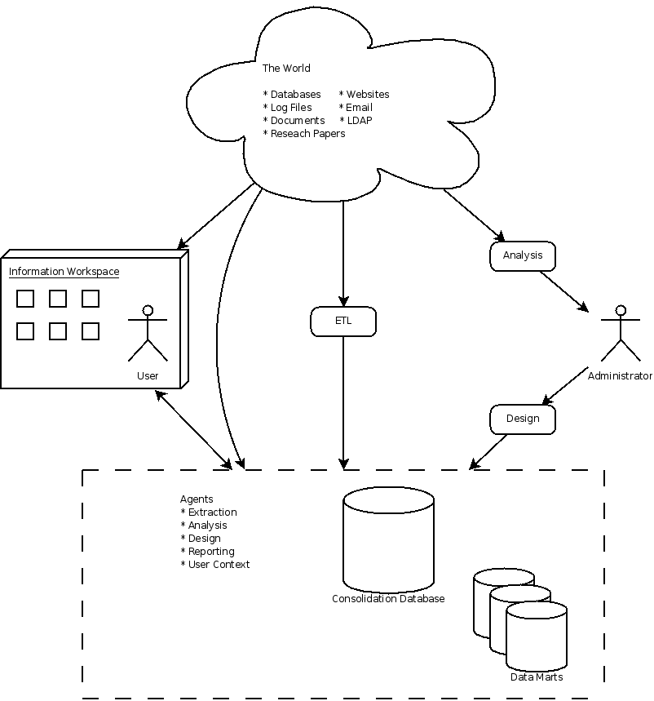

User Workflow
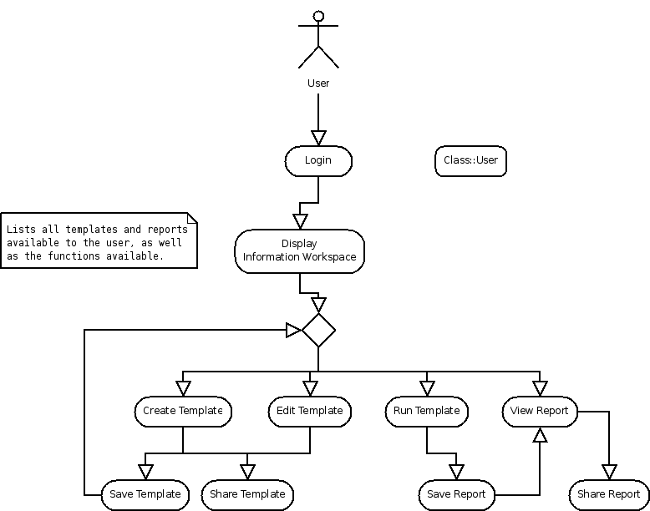
A user workflow diagram showing the primary functionality of the system.

Administration Workflow
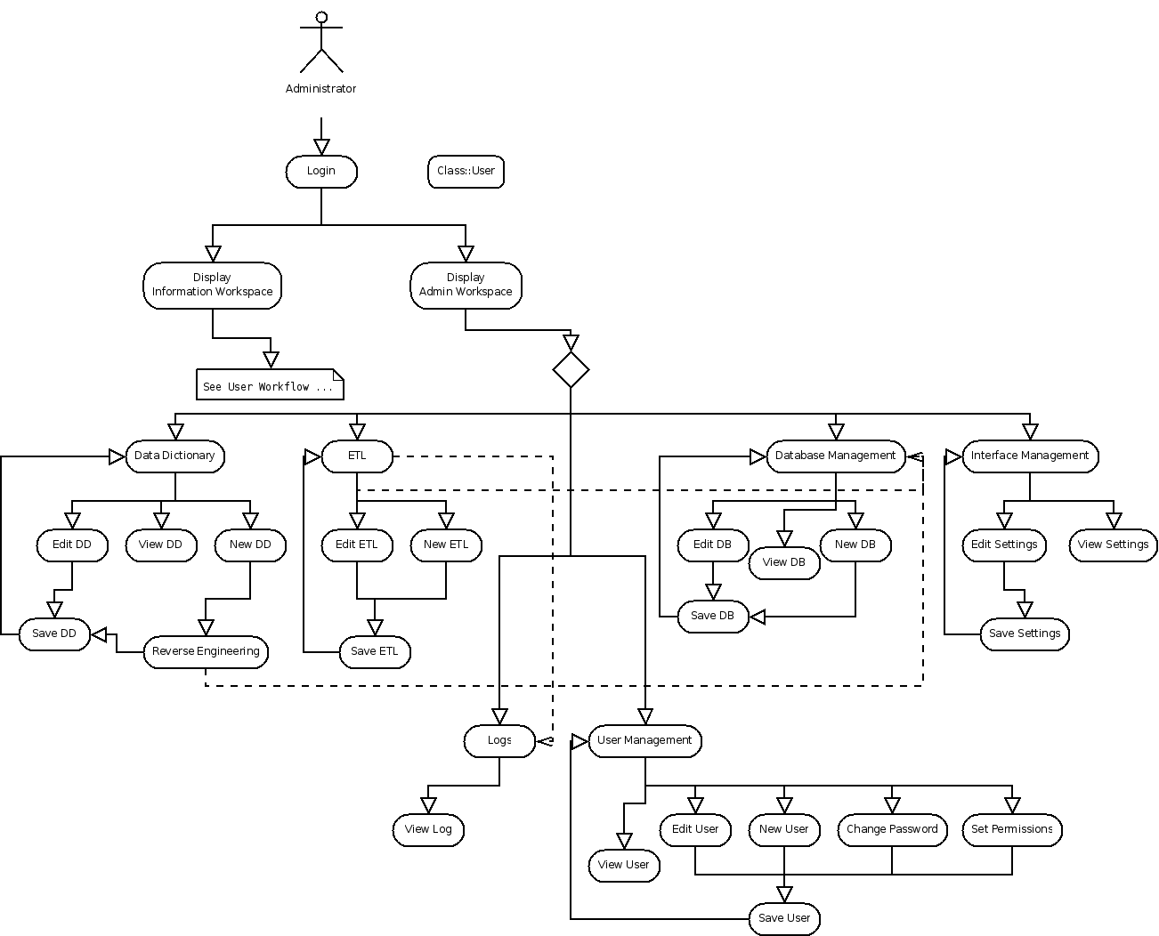
A user workflow diagram showing the primary functionality of the system, and what is available to an administration user.

System Design

Class Diagram
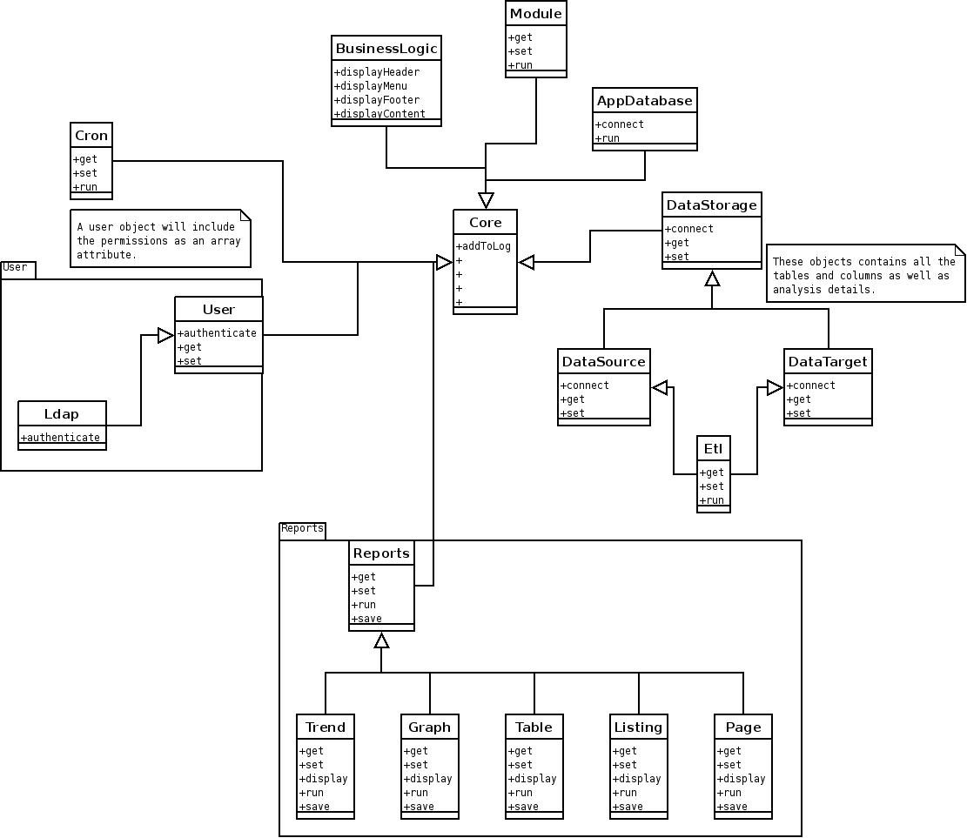

Authentication
Authentication will be handled by a variety of mechanisms, including:
- Local ACL – An Access Control List specified locally, within the IronData Core
- LDAP – From an organisation's LDAP Server
- Kerberos
- Any combination of the above

Technically Innovative Features

Artificial Intelligence and Data Warehousing
To the best of our knowledge, no data warehouse framework or product commercially available uses artificial intelligence techniques of any considerable complexity, despite the fact that the efficacy of these techniques has been proven time and again over the course of the last 50 years. We believe that we can deliver a unique new set of AI algorithms, and substantially add to the body of knowledge of data warehousing practitioners by doing so through the experience we gain.
There are several new techniques that have yet to see widespread implementation that would be interesting to follow-up with a project of this nature; Numenta's Hierarchical Temporal Memory implementation seems a prime candidate. This would require the licensing of their technology, but it would be a novel implementation of that technique.

Open-Source Data Warehouse Framework
As of the time of writing, there are no open source frameworks for data warehousing available. There are a variety of tools which, in isolation or together, can be used to create a data warehouse and associated reporting mechanisms, but there is no single framework to provide the middleware for all of these projects.

Zero Configuration Techniques in Enterprise Applications
Very few enterprise-grade applications or frameworks have been built that make use of technologies like ZeroConf (also known as Bonjour or, previously, Rendezvous). These technologies allow services on a network to discover one another using a protocol of announcements and referrals. We believe we will provide a strong case for implementing these technologies outside of home-user applications.

Modules
Modules can register with the core of IronData, and it is these which implement all the functionality. Some functionality is embedded within the Core, but this functionality can also be extended by modules.
Modules can also extend other modules. For example the user module can be extended by a high-security module which impliments two factor authentication.

Administration

Modules
- A list of current and existing modules
- The ability to install and remove modules
- Configure Module Permissions

Users and Groups
- Add, remove, edit users
- Add, remove, edit groups
- Change passwords
- Modify user application settings
- Assign users to groups
- Import LDAP groups

Scheduler
- Assign/Remove tasks to the schedular (think cron).
- View scheduled tasks

Settings
- View and modify system settings

Access Logs
- View access logs
- Filter access logs

Site Maintenance
- Disable the site and place it into maintenance mode, accessible only by admin

Catalogue
The catalogue modules contains definitions and representations of data elements . It defines the human meaning of data (through semantic analysis and human input). It defines how data elements are stored in the metabase.
It should be comprehensive and simple to understand and define historical data and structure.

Data Sources and Targets
Source List
A list of all available data sources and targets. Each data source type is a seperate module.
Each is listed in a table.
Number | Name | Type | Icons | Number of Records
... | ... | ... | ... | ... ->

The new pane exists above the table.

Data Dictionary
- A list of the columns and tables within each source and target.

ER Diagrams
- A display of the DD as a diagram

Data Explorer
- A view allowing the user to write SQL

Reverse Engineering
This process involves extracting and building metadata on all the available relations and the relationships between elements. From this is creates a complete data model and a data dictionary for future reference.

ETL
Extraction is the first step in the ETL process . Different data types have different extraction methods, and those details will be under the types module.

Rules
Transformation is the second step in the ETL process. A series of rules are applied to each row
- Adding arbitrary content
- Removing arbitrary content
- Modifying the content of the cell.
- Splitting a cell into two.
- Joining cells together.
- Dropping an entire row from insertion.
Load is the final step in the ETL process. Any triggers are fired as each row is inserted. Depending on the triggers and indexes, this can be very time-consuming. It may be faster to drop all the indices on the tables for the load and recreate them after the ETL process.

Historical Extraction
In principle, the Data Warehouse should contain a complete historical log of the original data. IronData needs to deal with
- A record may store the fact that it is no longer current, e.g. cancelled.
- A record may store the modified by and time, but not the changes.
- A record may store the changes in a audit log file, which may be difficult to process and extract from.

Reports

Trend Reports

Graph Reports

Table Reports

List Reports

Comparison Reports

SQL Reports

Files

Upload

View

Search

RSS Publishing

Communications

Email

SMS

Context / Metadata

Forward

Printer Friendly

Legal

Authentication
Authentication is through a username/password system. Once registered each user is given a token for the current session. Each XML request for that user, must pass that session id.

Communication
Connection between the IronData application and any of the Interfaces is through standard Unix sockets. The communication through these is through a custom XML schema.

Requests
<request> --The request wrapper
<session></session> --The session id for the user
<module name=''> -- The module to run
<command name=''> -- The Command/Request to pass.
-- Specific command parameters. Specified by the module. <element name=''></element>
<...etc...>
</command>
</module>
</request>
Any number of command blocks can be passed per module, and any number of module can be called in the same XML request.

Response
<response> --The response wrapper
<module name='' region='' id='' title=''> -- The module to run
... -- Display elements
</module>
</response>

Response Elements
Display Element | Attributes | Description
Menu | - content - A list of menu items  - name - The name of the menu | Displays a menu block. This is a special block filled with menuitems.
MenuItem | - content - The text of the menu item  - module - The module to run  - name - The name (as action) of the event | A list of local events.
Para | - content - The content to wrap | The paragraph wrapper
Text | - content - The text to display  - style - The style to apply (eg bold) | The paragraph wrapper
Header | - content - The text to display in the header
Preimage | - content - The name of the predefined image | An element displaying a predefined image. These are standard images within irondata
Input | - content – The label of the input field  - type – The type of field. Can be text, password or submit.  - name – The name of the fields  - value – Predefined value of the field.
Form | - content – The form elements to wrap  - name – The name of the form
Ext_link | - content – The text to make into a link  - href – The URL to visit | An external link, or a link to another website.
Local_link | - content – The text to make into a link  - module – The module to call  - view – The view within the module to call  - action – The action within the view within the module to call
Br |  | A single line break.
Table_cell | - content – The elements to place in the cell.  - id – The ID of the cell  - border – The sides to place a border on. Can be l, r, t, b  - span – How many columns to spam.
Table_row | - content – The cells to place in the row.
Table | - content - The rows to place in the table.  - id - The ID of the cell  - border – The sides to place a border on. Can be l, r, t, b
Pane | - content – The elements to place in the pane  - name – The name of the pane  - status – Collapsed or expanded | A collapsable content pane.

Graphic Design
Under Development.
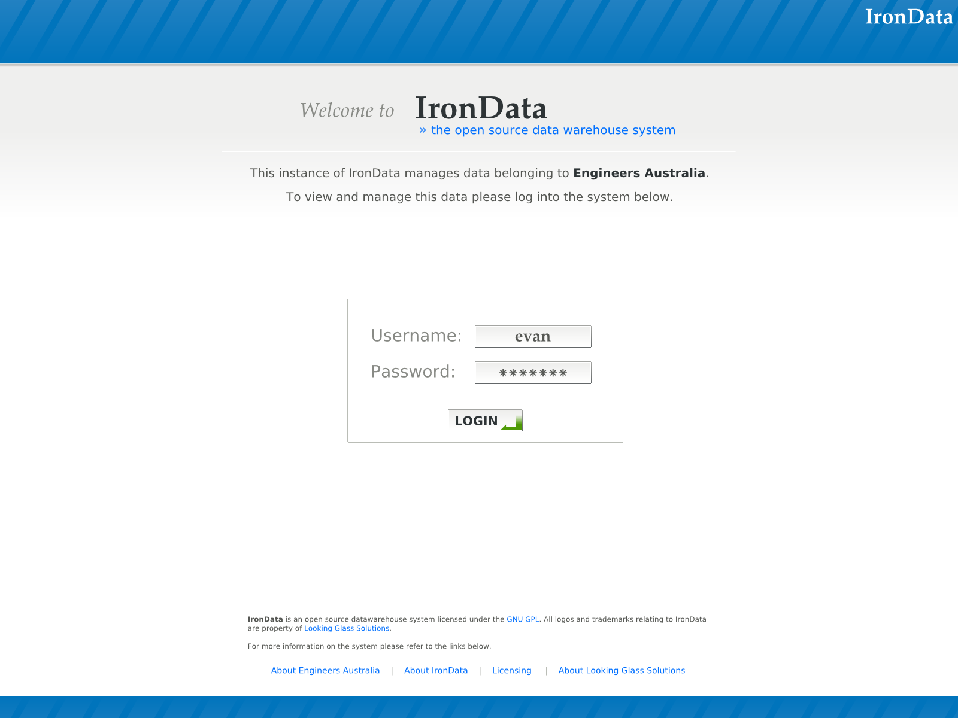
The login screen
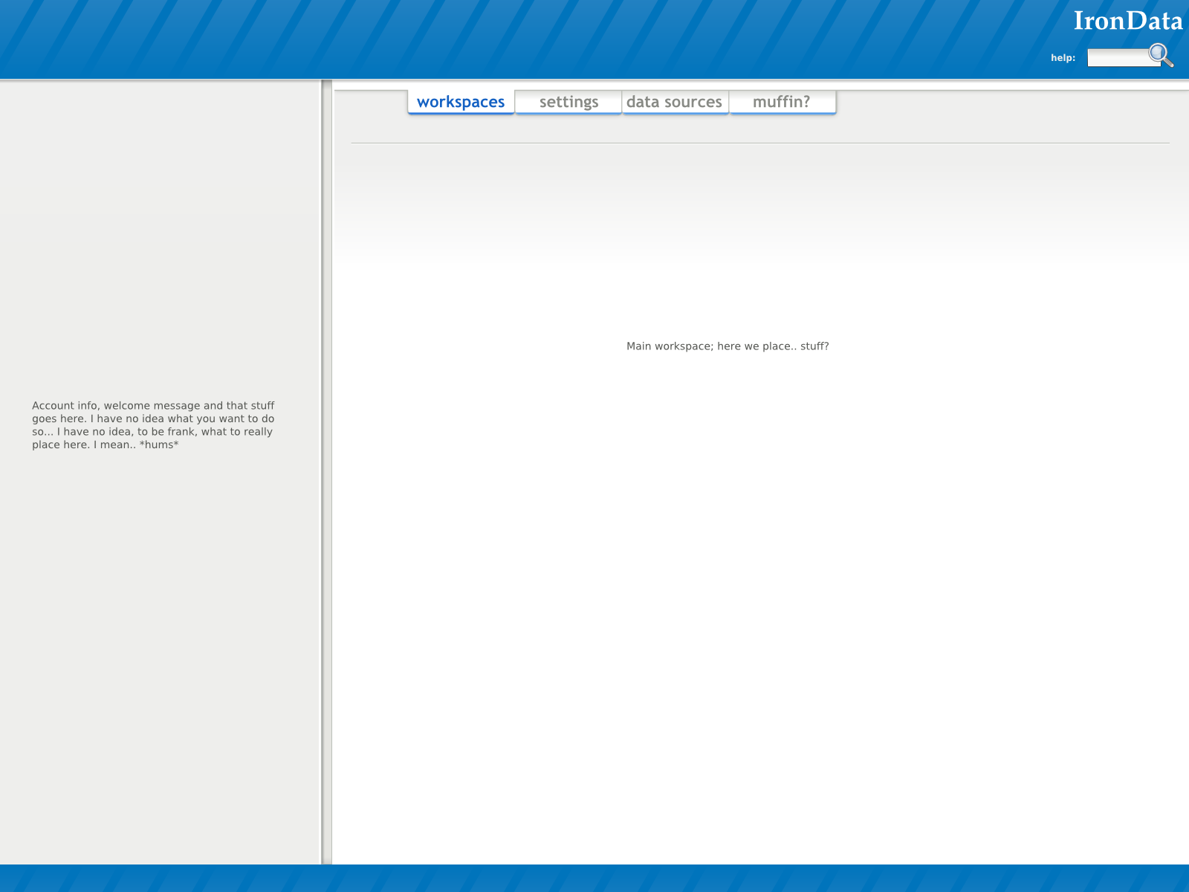
The main layout.

Competitor Companies and Projects
The following is a list of competing Open-Source projects and commercial products in the Data Warehouse sphere. Further analysis of their offerings and how we can better place ourselves as a competitor should be undertaken as part of this project.

Open Source
- Pentaho
- Jasper Reports
- YALE
- OpenI

Commercial
- Business Objects
- Netezza
- SAP Business Information Warehouse
- Teradata

Risk Analysis
The following is an analysis of various key risks associated with the project. These risks are only a small sampling of a full risk analysis, and a more full risk analysis should be undertaken at the earliest possible opportunity.
Project Failure due to Lack of Funding
Description: At present, IronData lacks sufficient community support to gain traction as an alternative to big-end competitor platforms. The development team consists essentially of two people, working only occasionally, and additional funding is required to get the project going further.
Mitigation Strategy: Sources of funding must be further investigated. This includes various government grants, which may be amenable to our goals, community support, support from larger business ventures, potential customers willing to sponsor development and/or some sort of investment.
Probability: Medium/High
Impact: High
Risk: High

Artificial Intelligence Algorithm Inefficiency
Description: It is possible that planned AI techniques may not be sufficiently efficient for deployment in a production environment. The use of such techniques in this field (owing to their fairly advanced nature and the complexity of the data sets typically used) has not seen widespread adoption, and we are to some extent cutting new ground by doing so.
Mitigation Strategy: Further research into the algorithmic efficiency of the techniques proposed should be investigated as early as possible. Where possible, alternative techniques and algorithms should be investigated that could replace AI techniques if they prove to be inefficient or otherwise unusable.
Probability: Low
Impact: Critical
Risk: High

Competitor Movement
Description: It is possible that a competitor (for example, Oracle or Business Objects) could adopt an open-source project that would cause significant loss of interest in a project of this nature. To our knowledge, no competitor has expressed any interest in the Open Source domain.
Mitigation Strategy: Early vocal marketing could trump a competitor entering our business space, if we can gain either first-mover advantage, and/or widespread community support.
Probability: Medium/Low
Impact: High
Risk: Medium

Community Disinterest
Description: The Open Source community may not be interested in a Data Warehouse framework, and see it as something that is not worth supporting or further enhancing. If this occurs, the long-term value of the project to clients and investors will be reduced (but not entirely cancelled).
Mitigation Strategy: As we have done, discussion of the project at community events will raise awareness and interest before the project is complete. Further consultation with the community and interaction with other related projects will ensure mutual interests and lead to continued community support. Finding additional 'future clients' will also ensure interest and support (and may generate funding, see above).
Probability: Medium
Impact: Medium
Risk: Medium

Poor Usability
Description: The user interface of the project is a major selling point. If the interface is cumbersome or difficult to use, potential client organisations will opt not to use the system, and we lose potential support and development contracts.
Mitigation Strategy: The user interface should be prototyped and tested as early as possible. It should be developed alongside other modules and features, and tested extensively with both expert and non-expert audiences to ensure maximum usability by a range of users and experience levels.
Probability: Medium
Impact: High
Risk: High

Roadmap
The roadmap for the early stages. This is a very rough roadmap, and assumes only two people working on the project. Additional staff will mean that we can get a lot more done – especially more rigorous testing.
Apr – Aug 2006: Metabase Design
Jun – Oct 2006: ETL Design
Jan – Aug 2007: Core System
Aug - Oct 2007: Interface Design
Aug – Dec 2007: Catalogue
Oct – Jan 2008: Metabase Generator
Jan 2008 – May 2008: ETL
Mar 2008 – Aug 2008: Information Workspace

